RUS Success Stories: Village of Grassy Sound

Town of Middle
County of Cape May, New Jersey

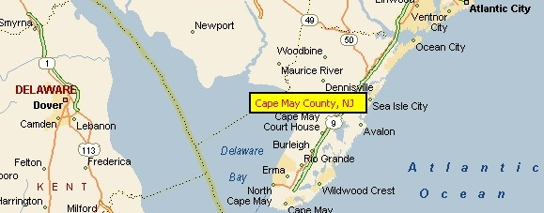

Outline of Need: In 1991, the New Jersey Department of Environmental Protection required the Village of Grassy Sound to install electrical, chemical, gas or compost toilets for the 40-50 homes that were constructed on pilings over a salt marsh; access to the homes was provided via a boardwalk. Past disposal for sewage and other household wastewater consisted of chamber pots and outhouses that discharged directly into the tidewater/saltwater marsh area beneath the homes. A permanent solution was needed.

How RD Helped: The Village of Grassy Sound Civic Association approached USDA Rural Development for assistance from the Rural Utilities Service Water and Waste Disposal program. Rural Development awarded a $440,370 grant for the construction of a permanent sewage collection system. The system serves 55 residential units and is composed of low-pressure grinder pumps leading to temporary holding tanks for disposal of the effluent at the regional wastewater treatment plant. This system was also funded with a substantial applicant contribution and a grant from the State of New Jersey. USDA also provided an additional $90,000 in grant funds for a cost overrun.

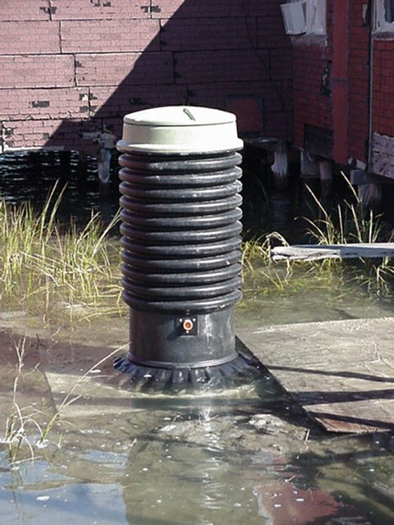
The Results: Phase I of the project has been completed. The residents of the Village of Grassy Sound now enjoy something most of the U.S. takes for granted. The planning continues for a permanent connection to dispose of the effluent. Once the legalities have been worked out, USDA expects to be a part of Phase II to further assist the residents of this needy community.

